Part 1: Black Box Testing

Input Partitioning
List all the combinations of the equivalence classes for input parameters (arr and x):
Partition | Equivalence Class for arr | Equivalence Class for x
P1 | an array no more than 100 unique integers sorted in ascending order | x is in the array
P2 | an array no more than 100 unique integers sorted in ascending order | x is out of the array
P3 | an array no more than 100 unique integers sorted in ascending order | x is not an integer
P4 | arr = null | Any
P5 | an array is not no more than 100 unique integers sorted in ascending order | Any

List the test cases you designed to cover all the identified partitions. Test cases might be fewer than the partitions.
Test | Partitions covered | arr input | x input | output
T1 | P1 | [1,2,3] | 1 | 0
T2 | P2 | [1,2,3] | 4 | -1
T3 | P3 | [1,2,3] | 2.2 | Exception
T4 | P4 | NULL | 1 | Exception
T5 | P5 | [3,2,1] | 1 | Exception

Output Partitioning
List all the partitions, i.e., equivalence classes for the output domain.
Partition | Equivalence Class for output
P1 | -1
P2 | J
P3 | Exception

List the test cases you designed to cover all the identified partitions. The test cases might be fewer than the partitions.
Test | Partitions covered | arr input | x input | output
T1 | P1 | [1,2,3] | 4 | -1
T2 | P2 | [1,2,3] | 1 | 0
T3 | P3 | null | 1 | Exception
T4 | P3 | [1,3,2] | 1 | Exception
T5 | P3 | [1,2,3] | x | Exception

Boundary Value Robustness Testing
Test cases designed based on all combinations of boundary values for arr and x.
Test | arr input | x input | output
T1 | null | 1 | Exception
T2 | [1] | 1 | 0
T3 | [1] | 2 | -1
T4 | [1,2,…,100] | 1 | 0
T5 | [1,2,…,100] | 100 | 99
T6 | [4,6,8] | 3 | -1
T7 | [4,6,8] | 9 | -1
T8 | [4,6,8] | 5 | -1
T9 | [1,2,…,101] | 1 | Exception
T10 | [4,4,8] | 1 | Exception
T11 | [4,8,6] | 1 | Exception
T12 | [4,6,8] | x | Exception

Part 2: White Box Testing

Statement Coverage
Python
Please indicate which language version of source code you are using:
Below is the code I used:
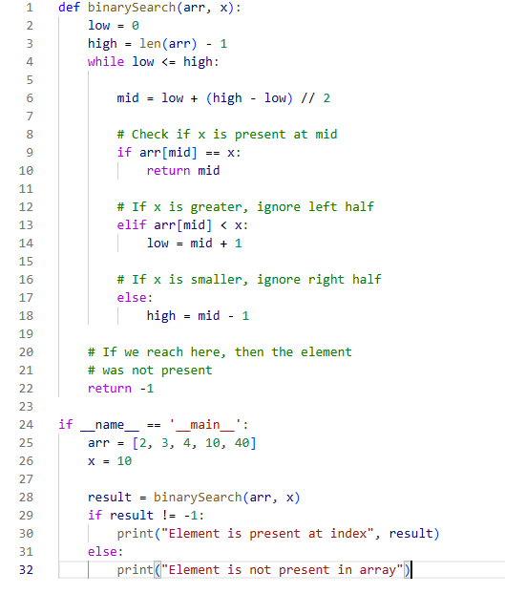

List the test cases designed following the Statement Coverage method.
Test | Statement (line#) covered | arr input | x input | output
T1 | 1,2,3,4,22 | [] | 1 | Element is not present in array
T2 | 2,3,4,6,9,10 | [1] | 1 | Element is present at index 0
T3 | 2,3,4,6,9,13,14 | [1,2,3,4,5] | 5 | Element is present at index 4
T4 | 2,3,4,6,9,17,18,22 | [1,2,3,4,5] | 6 | Element is not present in array

Decision Coverage
Python

Please indicate which language version of source code you are using:
Identify all sides of every decision point, and the inputs that result in each decision side:
ID | Decision | arr input | x input
D1 | while (low <= high) true | [1] | 1
D2 | while (low <= high) false | [1, 2, 3, 4, 5] | 6
D3 | if (arr[mid] == x) true | [1] | 1
D4 | if (arr[mid] == x) false | [1, 2, 3, 4, 5] | 6
D5 | elif (arr[mid] < x) true | [1, 2, 3, 4, 5] | 6
D6 | elif (arr[mid] < x) false | [1, 2, 3, 4, 5] | 1

List the tests you designed to cover the decisions in the above table. Test cases might be fewer than the decisions.
Test | Decisions covered | arr input | x input | output
T1 | D1, D3 | [1] | 1 | Element is present at index 0
T2 | D1, D2, D4, D5 | [1, 2, 3, 4, 5] | 6 | Element is not present in array
T3 | D1, D4, D6 | [1, 2, 3, 4, 5] | 1 | Element is present at index 0

Loop Coverage
Python

Please indicate which language version of source code you are using:
Identify different cases for the loop structure, design inputs to result in each case, and finally, figure out the expected output for each input.
Test | Loop body | arr input | x input | Output
T1 | zero times | [] | 1 | Element is not present in array
T2 | once | [1] | 1 | Element is present at index 0
T3 | multiple times | [1,2,3,4,5] | 5 | Element is present at index 4
T4 | multiple times | [1,2,3,4,5] | 1 | Element is present at index 0

Path Coverage
Python

Please indicate which language version of source code you are using:
Identify all possible paths:
Path | Line# in the path
PT1 | 2,3,4,22
PT2 | 2,3,4,6,9,10
PT3 | 2,3,4,6,9,13,14,4,6,9,10
PT4 | 2,3,4,6,9,13,16,17,4,6,9,10
PT5 | 2,3,4,6,9,…,4,22
List the test cases you designed to cover all the identified paths:
Test | Paths covered by test | arr input | x input | Output
T1 | PT1 | null | 1 | Element is not present in array
T2 | PT2 | [1] | 1 | Element is present at index 0
T3 | PT3 | [1,2,3,4,5] | 5 | Element is present at index 4
T4 | PT4 | [1,2,3,4,5] | 1 | Element is present at index 0
T5 | PT5 | [1,2,3,4,5] | 6 | Element is not present in array

